Data Structures
Homework Assignment No. 4
Instructor Teacher：M. B. Lin

Graph……………………………1~4

Problem 1………………………5~30

一、Generate randomly a graph with at least 20 vertices……………5
二、Depth first search…………………………………………………9
三、Breadth first search………………………………………………11
四、Total program and running results………………………………15

Impressions of gains……………31
※圖形結構（graph）：
由頂點（vertices）與邊（edges）兩部分所構成。
（一）無向圖（undirected graph）：
邊的兩個頂點沒有次序的關係。
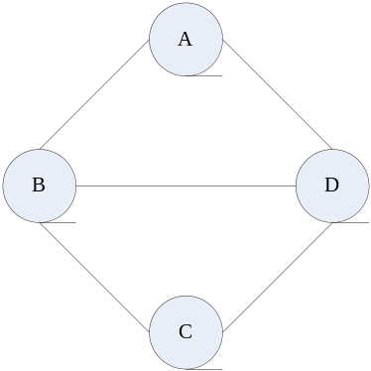
GRAPH ONE
（二）有向圖（derected graph）：
邊的兩個頂點有著次序關係。
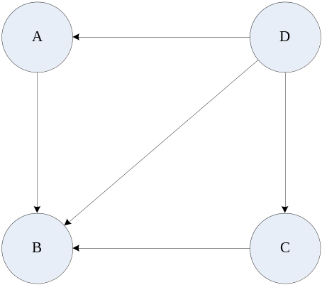
GRAPH TWO
（三）圖形表示法：
1、相鄰矩陣（adjacent matrix）：
利用一個大小是N的二維陣列DATA來表示一個包含N個頂點的圖形。
 |  | A | B | C | D
A |  | 0 | 1 | 0 | 1
B |  | 1 | 0 | 1 | 1
C |  | 0 | 1 | 0 | 1
D |  | 1 | 1 | 1 | 0
GRAPH ONE

 |  | A | B | C | D
A |  | 0 | 1 | 0 | 0
B |  | 0 | 0 | 0 | 1
C |  | 0 | 1 | 0 | 0
D |  | 1 | 0 | 1 | 0
GRAPH TWO
2、相鄰串列（adjacent list）：
利用串列結構來紀錄給定的圖形中頂點的相鄰關係。
將給定的圖形依照個別頂點與其他頂點的直接連接關係以鏈結串列來表示。因此一個節點包含頂點欄和鏈結欄兩部份，頂點欄放相鄰矩陣之行值，而鏈結欄則指向右邊的節點。
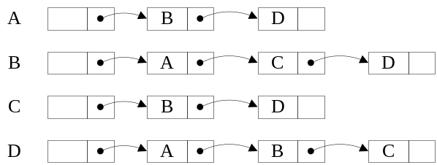
GRAPH ONE

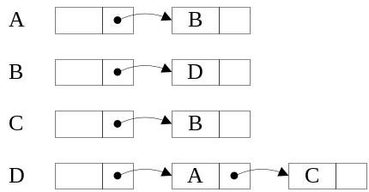
GRAPH TWO
3、相鄰複串列（adjacent multilist）：
相鄰複串列的個別節點則是用以表示給定圖形的一個邊的資料，因此相鄰複串列的節點又被稱為邊節點。
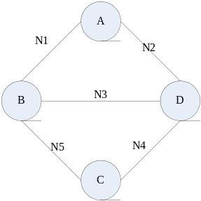
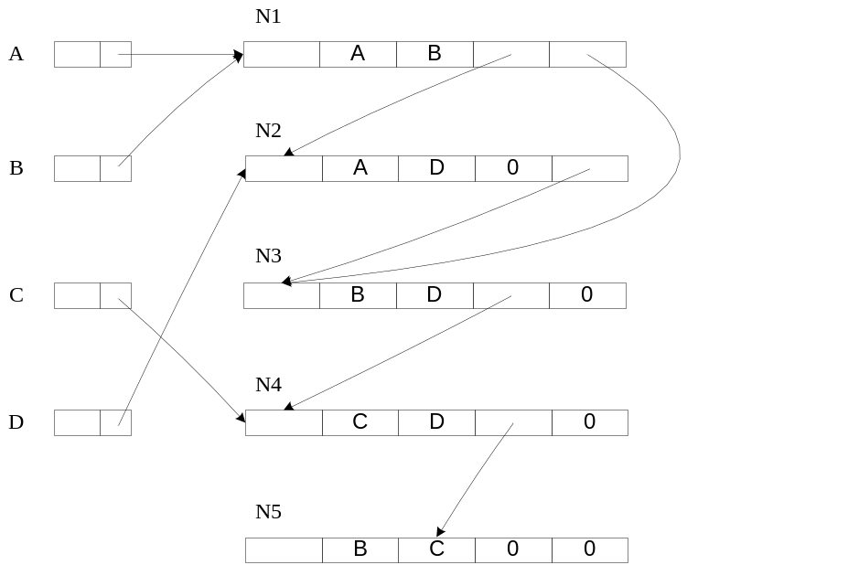
（四）圖形追踨（graph traversal）：
1、深度優先搜尋法（depth first search，DFS）：
在圖形搜尋的過程中會將搜尋的目標設定於與起始搜尋頂點相鄰的某一個頂點，再將選出的頂點當成搜尋的起始頂點並重複執行相同的搜尋程序。
2、廣度優先搜尋法（breadth first search，BFS）：
從起始搜尋頂點開始拜訪所有與之相連的頂點，再繼續與剛才拜訪過所有相鄰的下一層所有頂點，必須照相同的規則一層一層加以處理直到沒有任何相鄰的頂點。
（五）Declare new type of vertex of graph structure：
typedef struct graph
{
char vertex;
struct graph *link;
}
graph;
（六）Declare twenty head array of vertex：
graph head[20];
（七）Declare twenty save array of record visited：
short visited[20];
Problem One
一、Generate randomly a graph with at least 20 vertices：
（一）演算法流程圖：
1、Function that swap two number：
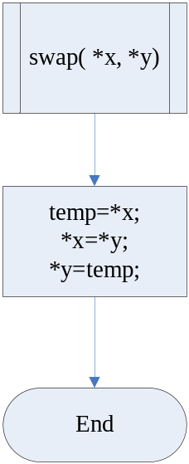
2、Function that add vertex adjacency lists of graph：
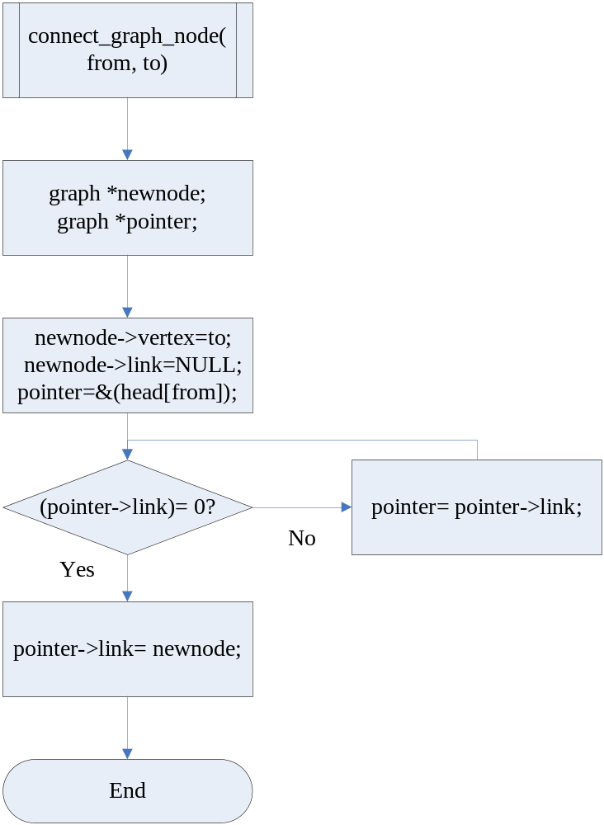
3、Function that start to create a random graph：
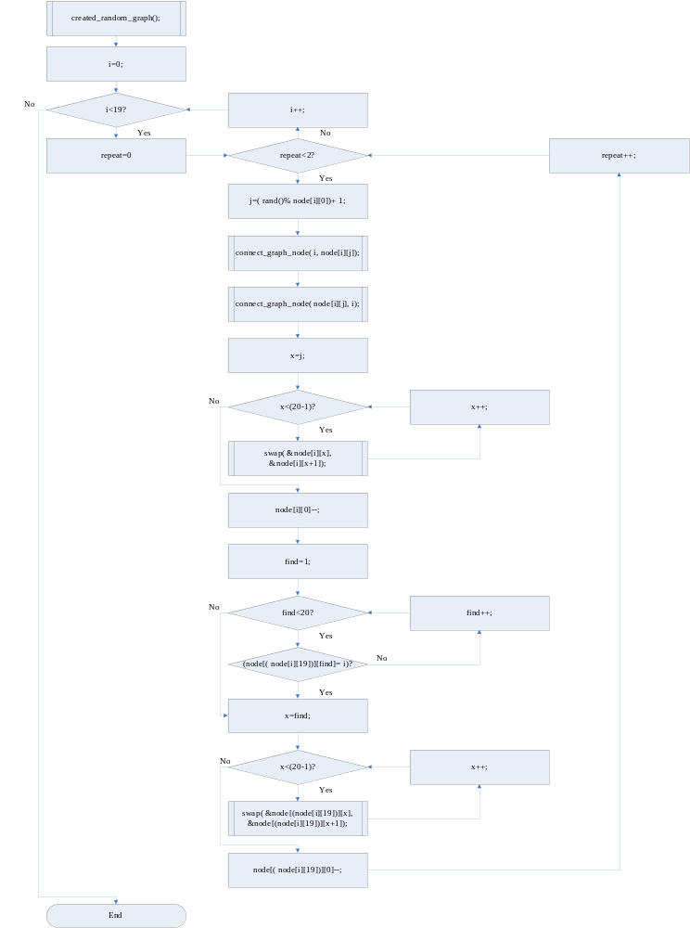
（二）程式碼：
0、Vertex random generation array：
char node[20][20]={{19,1,2,3,4,5,6,7,8,9,10,11,12,13,14,15,16,17,18,19}
,{19,0,2,3,4,5,6,7,8,9,10,11,12,13,14,15,16,17,18,19}
,{19,0,1,3,4,5,6,7,8,9,10,11,12,13,14,15,16,17,18,19}
,{19,0,1,2,4,5,6,7,8,9,10,11,12,13,14,15,16,17,18,19}
,{19,0,1,2,3,5,6,7,8,9,10,11,12,13,14,15,16,17,18,19}
,{19,0,1,2,3,4,6,7,8,9,10,11,12,13,14,15,16,17,18,19}
,{19,0,1,2,3,4,5,7,8,9,10,11,12,13,14,15,16,17,18,19}
,{19,0,1,2,3,4,5,6,8,9,10,11,12,13,14,15,16,17,18,19}
,{19,0,1,2,3,4,5,6,7,9,10,11,12,13,14,15,16,17,18,19}
,{19,0,1,2,3,4,5,6,7,8,10,11,12,13,14,15,16,17,18,19}
,{19,0,1,2,3,4,5,6,7,8, 9,11,12,13,14,15,16,17,18,19}
,{19,0,1,2,3,4,5,6,7,8, 9,10,12,13,14,15,16,17,18,19}
,{19,0,1,2,3,4,5,6,7,8, 9,10,11,13,14,15,16,17,18,19}
,{19,0,1,2,3,4,5,6,7,8, 9,10,11,12,14,15,16,17,18,19}
,{19,0,1,2,3,4,5,6,7,8, 9,10,11,12,13,15,16,17,18,19}
,{19,0,1,2,3,4,5,6,7,8, 9,10,11,12,13,14,16,17,18,19}
,{19,0,1,2,3,4,5,6,7,8, 9,10,11,12,13,14,15,17,18,19}
,{19,0,1,2,3,4,5,6,7,8, 9,10,11,12,13,14,15,16,18,19}
,{19,0,1,2,3,4,5,6,7,8, 9,10,11,12,13,14,15,16,17,19}
,{19,0,1,2,3,4,5,6,7,8, 9,10,11,12,13,14,15,16,17,18}};
1、Function that swap two number：
void swap(char* x,char* y)
{
char temp=*x;
*x=*y;
*y=temp;
}
2、Function that add vertex adjacency lists of graph：
void connect_graph_node(short from,short to)
{
graph *newnode,*pointer;
newnode=(graph*)malloc(sizeof(graph));
newnode->vertex=to;
newnode->link=NULL;
pointer=&(head[from]);
while(pointer->link)
{
pointer=pointer->link;
}
pointer->link=newnode;
}
3、Function that start to create a random graph：
void created_random_graph(void)
{
short i,repeat,j,x,find;
for(i=0;i<19;i++)
{
for(repeat=0;repeat<2;repeat++)
{
j=(rand()%node[i][0])+1;
connect_graph_node(i,node[i][j]);
connect_graph_node(node[i][j],i);
for(x=j;x<(20-1);x++)
{
swap(&node[i][x],&node[i][x+1]);
}
node[i][0]--;
for(find=1;find<20;find++)
{
if(node[(node[i][19])][find]==i)
{
break;
}
}
for(x=find;x<(20-1);x++)
{
swap(&node[(node[i][19])][x],&node[(node[i][19])][x+1]);
}
node[(node[i][19])][0]--;
}
}
}
（三）解說：
1、先製作一組頂點陣列，每一個頂點陣列的第零個元素裡面放置的值決定了產生出連接至下一個頂點的範圍。
2、然後每一個頂點的第一到第十九陣列元素即是產生的範圍，這個範圍則由每一個頂點的第零個陣列元素值決定。
3、隨機產生的頂點範圍不會出現包含自己的頂點數值，因為連接到下一個節點的線不會連接到自己。
4、在這個隨機產生圖形的程式之中，曾經產生過並且已經連接的頂點元素值將會被移動到最後面去，然後第零個元素所存的產生範圍值減去一，以後以產生範圍值為依據的產生函數將不會產生到最後的那個元素。
5、接下來被產生對應到的那個頂點也必須讓它連回去連接它的那個頂點，然後強制將等於連接它的那個頂點元素數值同樣的移動到最後面去，第零個元素減去一，讓它不會再被產生出來。
二、深度優先搜尋法（Depth first search）：
（一）基本概念：
給定某個特定的圖形以及起始搜尋頂點，深度優先搜尋法（DFS）在圖形搜尋的過程中會將搜尋的目標設定於與起始搜尋頂點相鄰的某一個頂點，再將選出的頂點當成搜尋的起始頂點並重複執行相同的搜尋程序。在圖形搜尋過程中任何一個頂點只能夠被拜訪一次，也就是說只能用來當成搜尋的起始頂點一次。
（二）處理步驟：
1、假設頂點Vx是起始搜尋頂點，設定此頂點已經被拜訪過。
2、從與起始搜尋頂點Vx直接連接且未被拜訪過的頂點中任一選出一個頂點。我們假設該頂點為Vy，我們會設定此頂點已經被拜訪過。並紀錄其前一個搜尋頂點是Vx，並以Vy為新的起點搜尋頂點進行深度優先搜尋。
3、如果與頂點Vx直接連接的頂點皆已經被拜訪過，則回到頂點Vx的前一個被搜尋頂點。假設此頂點是Vz，則以Vz為新的起點搜尋頂點進行深度優先搜尋。
（三）特性：
1、在深度優先搜尋法中，當我們拜訪一個節點發現所有與它相連的節點皆已經拜訪過了，就必須退回來前一次被搜尋的頂點，並搜尋這個節點是否有任何相鄰的節點未被拜訪。如果有發現存在未被拜訪的頂點，就以此頂點為搜尋起點進行深度優先搜尋法。否則會再退回前一次被搜尋的頂點，並重複相同的處理程序。
2、從上述的處理過程我們發現深度優先搜尋法必須紀錄圖形追踨過程之中被用來當成起始搜尋頂點的所有頂點。以及其相對的先後順序的資訊。我們發現可以利用堆疊（stack）來紀錄深度優先搜尋過程中的資訊，並以遞迴（recursive）的方式進行圖形追踨的處理。
3、由於每次均是任意選取一個和Vx相連的頂點當做新的起始搜尋頂點，因此深度優先搜尋的結果並非唯一。也就是說，會因為過程中選取不同的相鄰頂點而產生不同的結果。如果我們希望得到唯一的深度優先搜尋的結果，可以透過圖形的所有頂點加以編號並設定在選取相鄰頂點是一定要按照編號由大到小（或是由小到大）的順序，如此便能產生唯一的搜尋結果。
4、一個給定的圖形在經過深度優先搜尋法處理之後，若有一些頂點尚未被拜訪，則表示此圖形並不是一個相連的圖形；反之，這個圖形是一個相連的圖形（Connected graph）。也就是說透過深度優先搜尋法的追踨可以將給定的圖形分割成為一棵樹或是一片樹林，我們將這兩種狀況分別稱為深度優先擴張樹（Depth first spanning tree）以及深度優先擴張樹林（Depth first spanning forest）
（四）虛擬碼演算法：
以遞迴（recursive）的演算法敘述“深度優先搜尋”的程序如下：
————————————————————START————————————————————
procedure DFS(V)
//已知一擁有n個頂點的無向圖形G=(V，E)及一個起始值為零的陣列VISITED(n). 以下的演算法將拜訪頂點V所有能夠到達的頂點；其中圖形G及VISITED都是整體共用的（global）。//
VISITED(V) <- I
for each vertex W adjacent to V do
if VISITED(W)=0 then call DFS(W)
end
end DFS
————————————————————END————————————————————
（五）流程圖演算法：
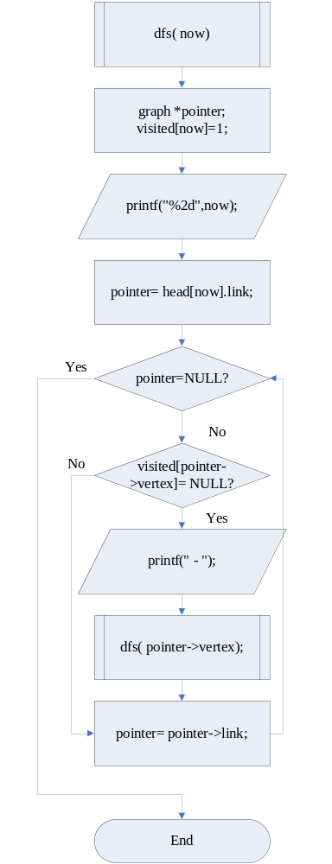
（六）程式碼：
void dfs(short now)
{
graph *pointer;
visited[now]=1;
printf("%2d",now);
pointer=head[now].link;
while(pointer)
{
if(!visited[pointer->vertex])
{
printf(" - ");
dfs(pointer->vertex);
}
pointer=pointer->link;
}
}
三、廣度優先搜尋法（Breadth first search）：
（一）基本概念：
給定一個圖形以及起始搜尋頂點，廣度優先搜尋法（BFS）是從起始搜尋頂點開始拜訪所有與之相連的頂點，再繼續與剛才拜訪過所有相鄰的下一層所有頂點，必須依照相同的規則一層一層加以處理直到沒有任何相鄰的頂點。也就是說，與起始搜尋頂點較鄰近（層次接近）的那些頂點會先被搜尋，而相對的較遠（層次較遠）的那些節點則較晚被搜尋。為了紀錄同一層次的節點相關資料方便循序的廣度優先搜尋處理，我們發現可以利用佇列（QUEUE）的結構來紀錄搜尋過程中的節點相鄰關係。
（二）處理步驟：
1、選擇一個起始頂點Vx，並設定此頂點已經被拜訪過。
2、將與Vx相連的所有頂點放入佇列。
3、若佇列不是空的則從佇列取出一個頂點Vy，並設定此頂點已經被拜訪過。並將與Vy相連且未拜訪過的頂點放入佇列中。
4、重複步驟3直到佇列是空的。
（三）特性：
1、由上面的介紹，我們發現廣度優先搜尋法BFS可以使用佇列（queue）的概念來搜尋相連的頂點，上一節所介紹的深度優先搜尋法DFS則是使用堆疊的概念來搜尋相鄰的頂點。
2、一個給定的圖形在經過廣度優先搜尋法處理之後，若有一些頂點尚未被拜訪，則表示此圖形並不是一個相連的圖形；反之這個圖形是一個相連的圖形（connected graph）。也就是說，透過廣度優先搜尋法的追踨可以將給定的圖形分割成為一棵樹或是一片樹林，我們將這兩種狀況分別稱為廣度優先擴張樹（breadth first spanning tree）以及廣度優先擴張樹林（breadth first spanning forest）。
（四）虛擬碼演算法：
已知Q是一個佇列（queue），本演算法用到兩個有關佇列的副程式，其功能分別如下：
————————————————————START————————————————————
A.AddQ(w,Q)—將資料w加到佇列Q中。

B.DELETEQ(v,Q)—從佇列Q中刪除一筆資料，並且將該筆資料的內容搬到v。

procedure BFS(v)
//已知一擁有n個頂點的無向圖形G=(V，E)及一個起始值為零的陣列VISITED(n)。以下的演算法敘述以頂點v為追踨的起始點之廣先搜尋圖形G，其中圖形G及陣列VISITED都是共用的。//
VISITED(v) <- 1
initialize Q to be empty //令Q一開始為一空的佇列//
loop
for all vertices w adjacent to v do
if VISITED(w)=0 then //若頂點w是尚未被拜訪過的頂點時
begin
call ADDQ(w,Q) //將w加到佇列Q中//
VISITED(w) <- 1 //拜訪頂點w//
end
end
if Q is empty then return //若佇列Q為空佇列則結束//
call DELETEQ(v,Q) //從佇列Q刪除一筆資料，並且將刪除的內容存在v//
forever
end BFS
————————————————————END————————————————————
（五）流程圖演算法：
1、Function that queue push data：
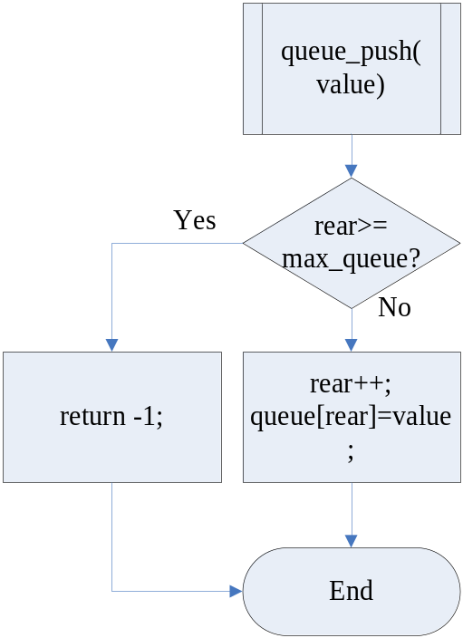
2、Function that queue pop data：
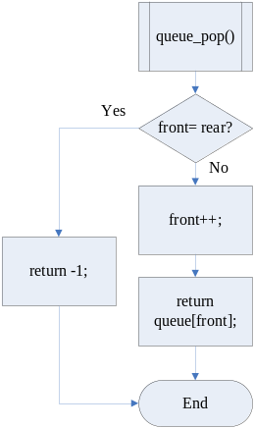
3、Function that breath-first search：
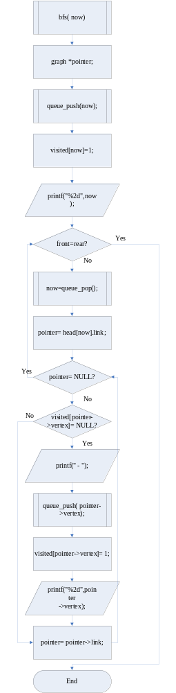
（六）程式碼：
1、Function that queue push data：
short queue_push(short value)
{
if(rear>=max_queue)
{
return -1;
}
rear++;
queue[rear]=value;
}
2、Function that queue pop data：
short queue_pop()
{
if(front==rear)
{
return -1;
}
front++;
return queue[front];
}
3、Function that breath-first search：
void bfs(short now)
{
graph *pointer;
queue_push(now);
visited[now]=1;
printf("%2d",now);
while(front!=rear)
{
now=queue_pop();
pointer=head[now].link;
while(pointer)
{
if(!visited[pointer->vertex])
{
printf(" - ");
queue_push(pointer->vertex);
visited[pointer->vertex]=1;
printf("%2d",pointer->vertex);
}
pointer=pointer->link;
}
}
}
四、Total program and running results：
（一）主程式流程圖演算法：
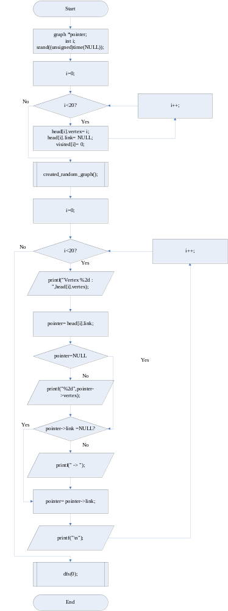
（二）深度優先搜尋法（Depth first search）：
1、Total program：
#include<stdio.h>
#include<stdlib.h>
//Declare new type of vertex of graph structure.
typedef struct graph
{
//Data of vertex.
char vertex;
//Pointer of next vertex.
struct graph *link;
}
graph;
//Declare twenty head array of vertex.
graph head[20];
//Declare twenty save array of record visited.
short visited[20];
//Vertex random generation array, array element zero of each vertex is determination magnitude of range.
//Array element from one to nineteen of each vertex are range of generation from array element zero determination.
//Range of vertex in array should not include vertex itself, because edge of graph can not connect itself.

//In this program, the element value produced will be moved to the last element,
//then generation range of element zero will reduce one, this element value will not be generated again.
//And then corresponding vertex generated that must let same vertex magnitude of element be moved to the last element too.
char node[20][20]=/*Vertex0*/ {{19,1,2,3,4,5,6,7,8,9,10,11,12,13,14,15,16,17,18,19}
/*Vertex1*/ ,{19,0,2,3,4,5,6,7,8,9,10,11,12,13,14,15,16,17,18,19}
/*vertex2*/ ,{19,0,1,3,4,5,6,7,8,9,10,11,12,13,14,15,16,17,18,19}
/*vertex3*/ ,{19,0,1,2,4,5,6,7,8,9,10,11,12,13,14,15,16,17,18,19}
/*vertex4*/ ,{19,0,1,2,3,5,6,7,8,9,10,11,12,13,14,15,16,17,18,19}
/*vertex5*/ ,{19,0,1,2,3,4,6,7,8,9,10,11,12,13,14,15,16,17,18,19}
/*vertex6*/ ,{19,0,1,2,3,4,5,7,8,9,10,11,12,13,14,15,16,17,18,19}
/*vertex7*/ ,{19,0,1,2,3,4,5,6,8,9,10,11,12,13,14,15,16,17,18,19}
/*vertex8*/ ,{19,0,1,2,3,4,5,6,7,9,10,11,12,13,14,15,16,17,18,19}
/*vertex9*/ ,{19,0,1,2,3,4,5,6,7,8,10,11,12,13,14,15,16,17,18,19}
/*vertex10*/ ,{19,0,1,2,3,4,5,6,7,8, 9,11,12,13,14,15,16,17,18,19}
/*vertex11*/ ,{19,0,1,2,3,4,5,6,7,8, 9,10,12,13,14,15,16,17,18,19}
/*vertex12*/ ,{19,0,1,2,3,4,5,6,7,8, 9,10,11,13,14,15,16,17,18,19}
/*vertex13*/ ,{19,0,1,2,3,4,5,6,7,8, 9,10,11,12,14,15,16,17,18,19}
/*vertex14*/ ,{19,0,1,2,3,4,5,6,7,8, 9,10,11,12,13,15,16,17,18,19}
/*vertex15*/ ,{19,0,1,2,3,4,5,6,7,8, 9,10,11,12,13,14,16,17,18,19}
/*vertex16*/ ,{19,0,1,2,3,4,5,6,7,8, 9,10,11,12,13,14,15,17,18,19}
/*vertex17*/ ,{19,0,1,2,3,4,5,6,7,8, 9,10,11,12,13,14,15,16,18,19}
/*vertex18*/ ,{19,0,1,2,3,4,5,6,7,8, 9,10,11,12,13,14,15,16,17,19}
/*vertex19*/ ,{19,0,1,2,3,4,5,6,7,8, 9,10,11,12,13,14,15,16,17,18}};
/****************************************/
/******Function that swap two number*****/
/****************************************/
void swap(char* x,char* y)
{
char temp=*x;
*x=*y;
*y=temp;
}
/************************************************************/
/******Function that add vertex adjacency lists of graph*****/
/************************************************************/
void connect_graph_node(short from,short to)
{
//Declare new vertex pointer.
graph *newnode,*pointer;
//Dispose memory space.
newnode=(graph*)malloc(sizeof(graph));
//Create content of vertex.
newnode->vertex=to;
//Set pointer initial value.
newnode->link=NULL;
//Let pointer point position of vertex.
pointer=&(head[from]);
//Vertex visited whether reach rear of list or not.
while(pointer->link)
{
//If no, point next list.
pointer=pointer->link;
}
//If yes, let newnode insert rear list.
pointer->link=newnode;
}
/************************************************************/
/********Function that start to create a random graph********/
/************************************************************/
void created_random_graph(void)
{
//Declare i point vertex, repeat is let i run two times, j point random vertex,
//x use to loop that let element generated move to the last element, find record vertex corresponding.
short i,repeat,j,x,find;
//Every vertex run two times.
for(i=0;i<19;i++)
{
for(repeat=0;repeat<2;repeat++)
{
//Determine this vertex will connect which vertex.
j=(rand()%node[i][0])+1;
//Start to create graph by connect vertex node.
connect_graph_node(i,node[i][j]);
//Connect vertex must be two-way, because one edge can connect two vertex.
connect_graph_node(node[i][j],i);
//Then let magnitude element generated move to the last element.
for(x=j;x<(20-1);x++)
{
//Change magnitude element and next element one by one.
swap(&node[i][x],&node[i][x+1]);
}
//Generation range of element zero will reduce one, to represent this element value will not be generated again.
node[i][0]--;
//Search vertex element from corresponding vertex generated.
for(find=1;find<20;find++)
{
if(node[(node[i][19])][find]==i)
{
//If find, break loop.
break;
}
}
//Then let magnitude element generated move to the last element.
for(x=find;x<(20-1);x++)
{
//Change magnitude element and next element one by one.
swap(&node[(node[i][19])][x],&node[(node[i][19])][x+1]);
}
//Generation range of element zero will reduce one too, to represent this element value will not be generated again.
node[(node[i][19])][0]--;
}
}
}
/****************************************/
/****Function that depth first search****/
/****************************************/
void dfs(short now)
{
//Declare new vertex pointer.
graph *pointer;
//Record vertex visited.
visited[now]=1;
//Print out vertex vedited.
printf("%2d",now);
//Let pointer point position of vertex.
pointer=head[now].link;
//Whether visit to rear of list or not.
while(pointer)
{
//If there are vertex have not visited.
if(!visited[pointer->vertex])
{
//Print out connected dash.
printf(" - ");
//Visit else vertex by recursive.
dfs(pointer->vertex);
}
//Pointer point next node.
pointer=pointer->link;
}
}
/****************************************/
/**************Main program**************/
/****************************************/
int main(void)
{
printf("\n---------------∮This program is-★-B9502028-★-陳敬翔-create∮---------------\n\n");
//Declare new vertex pointer.
graph *pointer;
//Declare loop control i.
int i;
//Srand randomized with time.
srand((unsigned)time(NULL));
for(i=0;i<20;i++)
{
//Set vertex value.
head[i].vertex=i;
//Clear graph pointer.
head[i].link=NULL;
//Set visited array initial value.
visited[i]=0;
}
//Create a graph.
created_random_graph();
printf("Content of adjacency lists of graph:\n");
for(i=0;i<20;i++)
{
//Print out magnitude of vertex.
printf("Vertex %2d : ",head[i].vertex);
//Point position of vertex.
pointer=head[i].link;
//Whether visit to rear of list or not.
while(pointer)
{
//Print out this content of vertex.
printf("%2d",pointer->vertex);
//If next pointer is not null.
if(pointer->link)
{
//Print out connected dash.
printf(" -> ");
}
//Point next vertex.
pointer=pointer->link;
}
//Give a paragraph.
printf("\n");
}
printf("\nContent of depth-first search:\n");
//Start to depth-first search.
dfs(0);
getch();
return 0;
}
2、Running results：
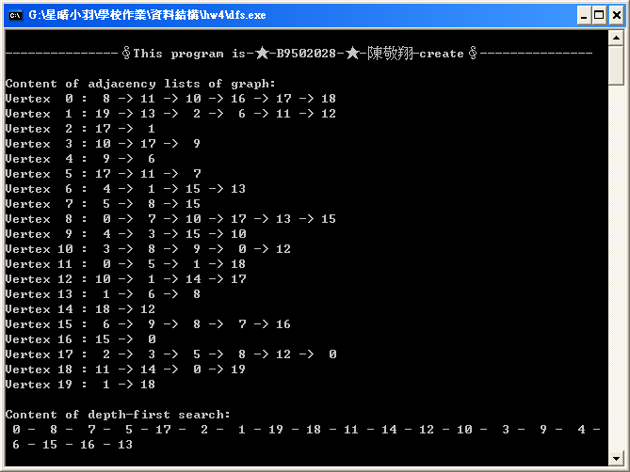
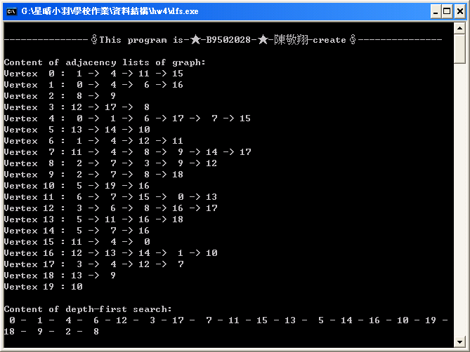
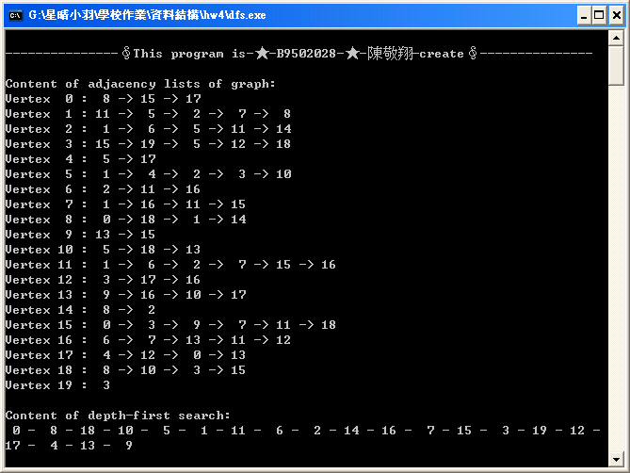
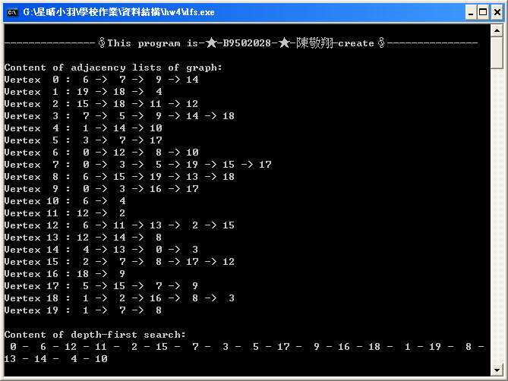
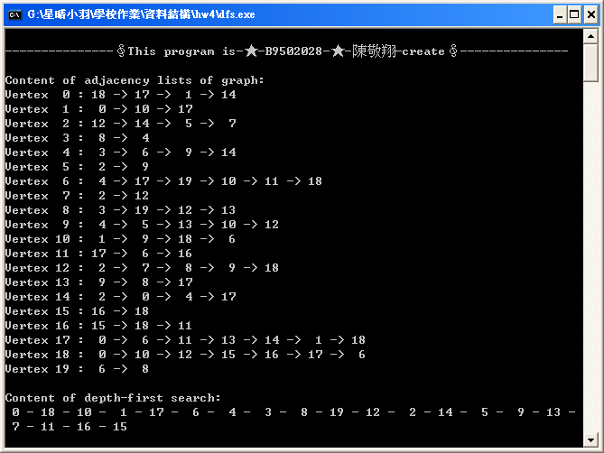
3、Graph（from the last running result）：
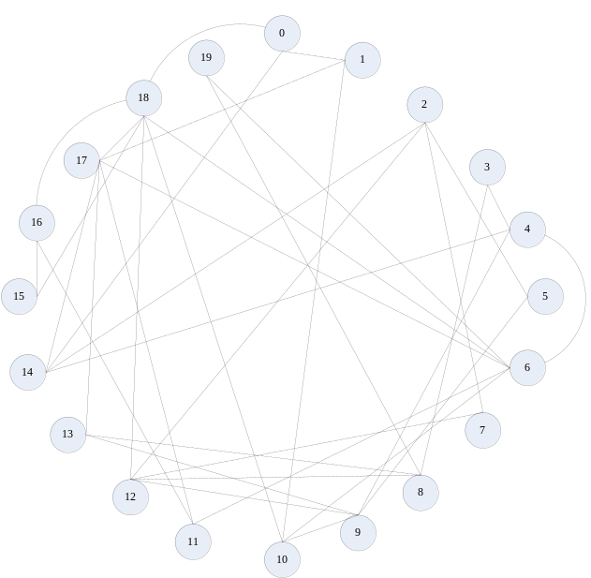
（二）廣度優先搜尋法（Breadth first search）：
1、Total program：
#include<stdio.h>
#include<stdlib.h>
#define max_queue 25
//Declare new type of vertex of graph structure.
typedef struct graph
{
//Data of vertex.
char vertex;
//Pointer of next vertex.
struct graph *link;
}
graph;
//Declare twenty head array of vertex.
graph head[20];
//Declare twenty save array of record visited, queue array, and queue pointer front and rear.
short visited[20],queue[max_queue],front=-1,rear=-1;
//Vertex random generation array, array element zero of each vertex is determination megnitude of range.
//Array element from one to nineteen of each vertex are range of generation from array element zero determination.
//Range of vertex in array should not include vertex itself, because edge of graph can not connect itself.

//In this program, the element value produced will be moved to the last element,
//then generation range of element zero will reduce one, this element value will not be generated again.
//And then corresponding vertex generated that must let same vertex magnitude of element be moved to the last element too.
char node[20][20]= {{19,1,2,3,4,5,6,7,8,9,10,11,12,13,14,15,16,17,18,19}
,{19,0,2,3,4,5,6,7,8,9,10,11,12,13,14,15,16,17,18,19}
,{19,0,1,3,4,5,6,7,8,9,10,11,12,13,14,15,16,17,18,19}
,{19,0,1,2,4,5,6,7,8,9,10,11,12,13,14,15,16,17,18,19}
,{19,0,1,2,3,5,6,7,8,9,10,11,12,13,14,15,16,17,18,19}
,{19,0,1,2,3,4,6,7,8,9,10,11,12,13,14,15,16,17,18,19}
,{19,0,1,2,3,4,5,7,8,9,10,11,12,13,14,15,16,17,18,19}
,{19,0,1,2,3,4,5,6,8,9,10,11,12,13,14,15,16,17,18,19}
,{19,0,1,2,3,4,5,6,7,9,10,11,12,13,14,15,16,17,18,19}
,{19,0,1,2,3,4,5,6,7,8,10,11,12,13,14,15,16,17,18,19}
,{19,0,1,2,3,4,5,6,7,8, 9,11,12,13,14,15,16,17,18,19}
,{19,0,1,2,3,4,5,6,7,8, 9,10,12,13,14,15,16,17,18,19}
,{19,0,1,2,3,4,5,6,7,8, 9,10,11,13,14,15,16,17,18,19}
,{19,0,1,2,3,4,5,6,7,8, 9,10,11,12,14,15,16,17,18,19}
,{19,0,1,2,3,4,5,6,7,8, 9,10,11,12,13,15,16,17,18,19}
,{19,0,1,2,3,4,5,6,7,8, 9,10,11,12,13,14,16,17,18,19}
,{19,0,1,2,3,4,5,6,7,8, 9,10,11,12,13,14,15,17,18,19}
,{19,0,1,2,3,4,5,6,7,8, 9,10,11,12,13,14,15,16,18,19}
,{19,0,1,2,3,4,5,6,7,8, 9,10,11,12,13,14,15,16,17,19}
,{19,0,1,2,3,4,5,6,7,8, 9,10,11,12,13,14,15,16,17,18}};
/****************************************/
/******Function that swap two number*****/
/****************************************/
void swap(char* x,char* y)
{
char temp=*x;
*x=*y;
*y=temp;
}
/************************************************************/
/******Function that add vertex adjacency lists of graph*****/
/************************************************************/
void connect_graph_node(short from,short to)
{
//Declare new vertex pointer.
graph *newnode,*pointer;
//Dispose memory space.
newnode=(graph*)malloc(sizeof(graph));
//Create content of vertex.
newnode->vertex=to;
//Set pointer initial value.
newnode->link=NULL;
//Let pointer point position of vertex.
pointer=&(head[from]);
//Vertex visited whether reach rear of list or not.
while(pointer->link)
{
//If no, point next list.
pointer=pointer->link;
}
//If yes, let newnode insert rear list.
pointer->link=newnode;
}
/************************************************************/
/********Function that start to create a random graph********/
/************************************************************/
void created_random_graph(void)
{
//Declare i point vertex, repeat is let i run two times, j point random vertex,
//x use to loop that let element generated move to the last element, find record vertex corresponding.
short i,repeat,j,x,find;
//Every vertex run two times.
for(i=0;i<19;i++)
{
for(repeat=0;repeat<2;repeat++)
{
//Determine this vertex will connect which vertex.
j=(rand()%node[i][0])+1;
//Start to create graph by connect vertex node.
connect_graph_node(i,node[i][j]);
//Connect vertex must be two-way, because one edge can connect two vertex.
connect_graph_node(node[i][j],i);
//Then let magnitude element generated move to the last element.
for(x=j;x<(20-1);x++)
{
//Change magnitude element and next element one by one.
swap(&node[i][x],&node[i][x+1]);
}
//Generation range of element zero will reduce one, to represent this element value will not be generated again.
node[i][0]--;
//Search vertex element from corresponding vertex generated.
for(find=1;find<20;find++)
{
if(node[(node[i][19])][find]==i)
{
//If find, break loop.
break;
}
}
//Then let magnitude element generated move to the last element.
for(x=find;x<(20-1);x++)
{
//Change magnitude element and next element one by one.
swap(&node[(node[i][19])][x],&node[(node[i][19])][x+1]);
}
//Generation range of element zero will reduce one too, to represent this element value will not be generated again.
node[(node[i][19])][0]--;
}
}
}
/****************************************/
/******Function that queue push data*****/
/****************************************/
short queue_push(short value)
{
//Inspect queue is whether full or not.
if(rear>=max_queue)
{
//If yes, return -1.
return -1;
}
//If no, let pointer move above.
rear++;
//And push this data.
queue[rear]=value;
}
/****************************************/
/******Function that queue pop data******/
/****************************************/
short queue_pop()
{
//Inspect queue is whether null or not.
if(front==rear)
{
//If yes, return -1.
return -1;
}
//If no, let pointer move above.
front++;
//And pop and return this data.
return queue[front];
}
/****************************************/
/****Function that breath-first search***/
/****************************************/
void bfs(short now)
{
//Declare new vertex pointer.
graph *pointer;
//Let vertex push to queue.
queue_push(now);
//Record vertex visited.
visited[now]=1;
//Print out vertex vedited.
printf("%2d",now);
//If queue is not null.
while(front!=rear)
{
//Get data from queue.
now=queue_pop();
//Let pointer point position of vertex.
pointer=head[now].link;
//Whether visit to rear of list or not.
while(pointer)
{
//If there are vertex have not visited.
if(!visited[pointer->vertex])
{
//Print out connected dash.
printf(" - ");
//Let vertex push to queue.
queue_push(pointer->vertex);
//Record vertex visited.
visited[pointer->vertex]=1;
//Print out vertex vedited.
printf("%2d",pointer->vertex);
}
//Pointer point next node.
pointer=pointer->link;
}
}
}
/****************************************/
/**************Main program**************/
/****************************************/
int main(void)
{
printf("\n---------------∮This program is-★-B9502028-★-陳敬翔-create∮---------------\n\n");
//Declare new vertex pointer.
graph *pointer;
//Declare loop control i,
int i;
//Srand randomized with time.
srand((unsigned)time(NULL));
for(i=0;i<20;i++)
{
//Set vertex value.
head[i].vertex=i;
//Clear graph pointer.
head[i].link=NULL;
//Set visited array initial value.
visited[i]=0;
}
//Create a graph.
created_random_graph();
printf("Content of adjacency lists of graph:\n");
for(i=0;i<20;i++)
{
//Print out magnitude of vertex.
printf("Vertex %2d : ",head[i].vertex);
//Point position of vertex.
pointer=head[i].link;
//Whether visit to rear of list or not.
while(pointer)
{
//Print out this content of vertex.
printf("%2d",pointer->vertex);
//If next pointer is not null.
if(pointer->link)
{
//Print out connected dash.
printf(" -> ");
}
//Point next vertex.
pointer=pointer->link;
}
//Give a paragraph.
printf("\n");
}
printf("\nContent of breath-first search:\n");
//Start to depth-first search.
bfs(0);
getch();
return 0;
}
2、Running results：
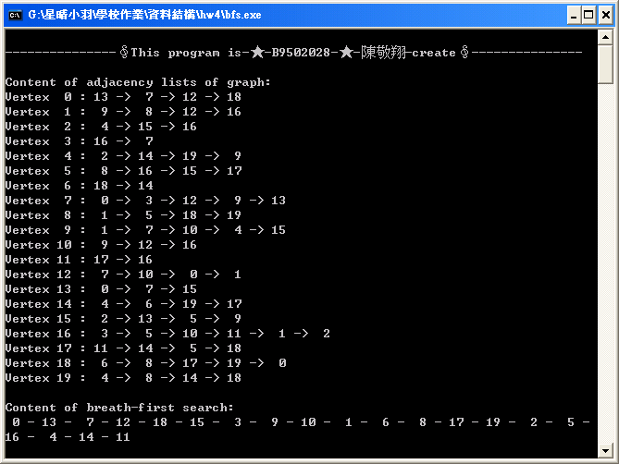
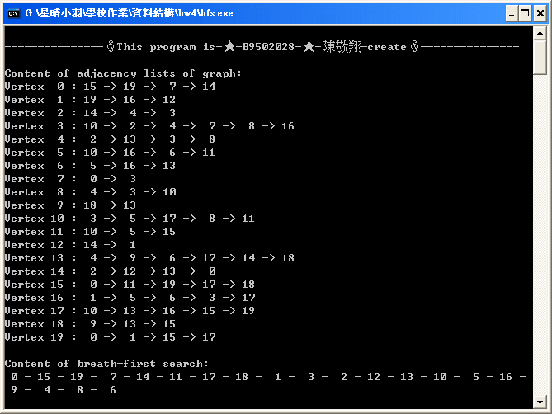
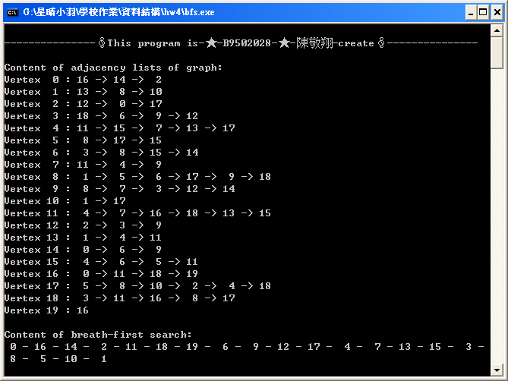
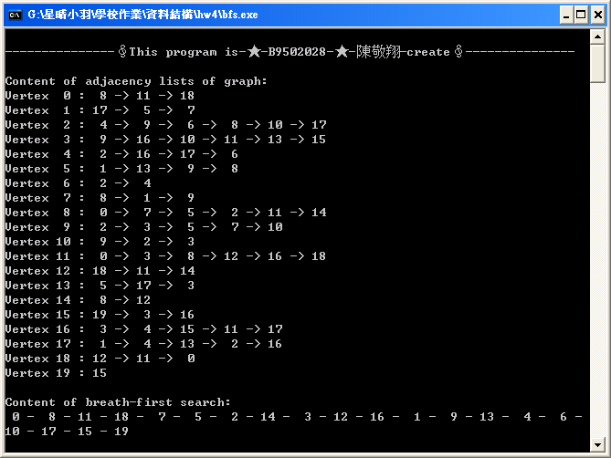
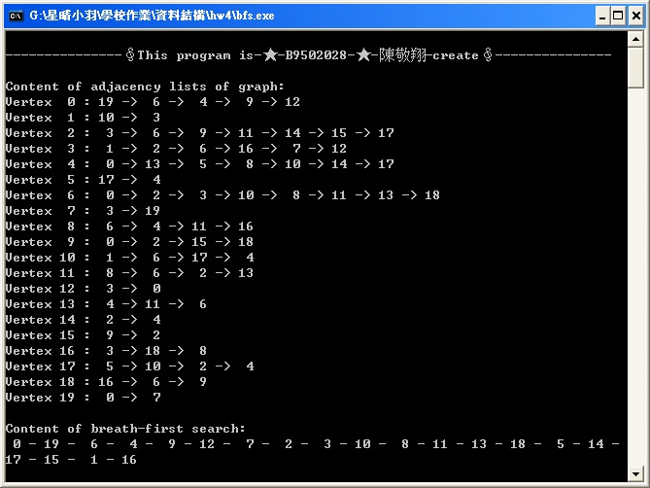
3、Graph（from the last running result）：
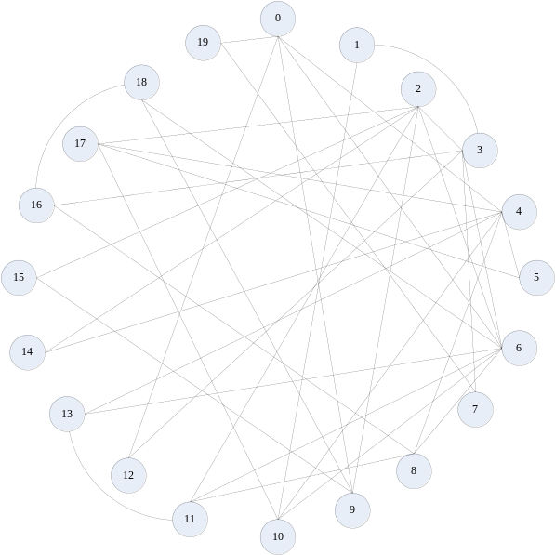
心得感想
這次是第四次作業，是探討一些圖形結構的相關問題，感謝老師給予這份作業，讓我們可以實際去操作，並且製作自己第一個圖形結構，除了探討圖形的搜尋探訪之外，還有日常生活上的應用，像是電路分析、IC板設計、城市間之交通網路規劃、晶體之化學結構分析、工程進度規劃以及作業研究等等。圖形結構的另一個特點是資料也可以儲存在圖形的個別邊上。邊上的資料可用以表示從這個邊的一個頂點至另一個頂點的花費（或成本）。這種將成本儲存在邊上的圖形又稱之為「網路」。
然而在製作過程中還有比較了圖形結構和樹狀結構。圖形結構中頂點和頂點之間的關係將不再是層次關係，取而代之的是連通的關係。如果兩個頂點之間有連通關係，就用一個邊將之相連！

在撰寫過程中，遇上了很多問題，因此花了很多時間去想，花了很多時間去尋求資料、去摸索、去理解、不斷的去嘗試，雖然過程艱辛的滋味難以言喻，但是完成的喜悅卻甘如露雨。
最後在逐一解決每個問題的同時，也讓自己的觀念越來越清楚，也學習得更多，再次感謝老師給了這樣的機會！上課辛苦了！

